Two Stack Sort

Problem Description
Tom has been working on an interesting sorting problem. As shown in the figure, with two stacks S₁ and S₂, Tom wants to sort the input sequence in ascending order with the help of the following 4 operations.
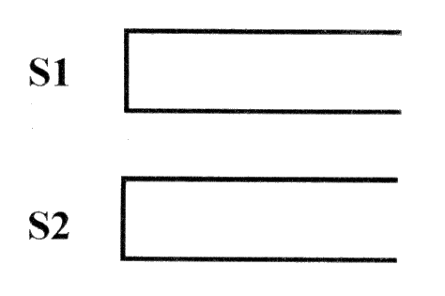
Operation a: If the input sequence is not empty, push the first element into stack S₁.

Operation b: If stack S₁ is not empty, pop the top element of stack S₁ to the output sequence.

Operation c: If the input sequence is not empty, push the first element into the stack S₂.

Operation d: If stack S₂ is not empty, pop the top element of stack S₂ to the output sequence.

If a 1~n permutation P can be manipulated so that the output sequence is (1, 2..., n-1, n), Tom calls P a “two-stackable sort permutation”. For example, (1,3,2,4) is a “two-stackable sort permutation”, while (2,3,4,1) is not. The following diagram depicts a sequence of operations “a, c, c, b, a, d, d, b” that sort (1,3,2,4).
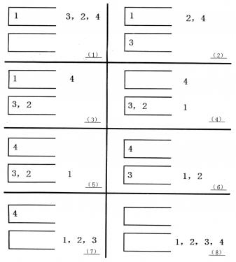

Of course, there may be several of such sequences of operations. For example, for (1,3,2,4), “a, b, a, a, b, b, a, b” is another feasible sequence of operations. Tom wants to know what the sequence of operations with the minimum dictionary order is.

Input
The first line of the input file is an integer n.

The second line has n positive integers separated by spaces, forming a permutation from 1 to n.

Output
The output file has one line, if the input is not “two-stackable sort permutation”, output 0.

Otherwise, output the sequence of operations with the minimum dictionary order, each two operations separated by a space, no space at the end of the line.

Sample Input 1
4
1 2 3 4

Sample Output 1
a b a a b b a b

Sample Input 2
4
2 3 4 1

Sample Output 2
0

Sample Input 3
3
2 3 1

Sample Output 3
a c a b b d

Hint
30% of the data meet: n ≤ 10.
50% of the data meet: n ≤ 50.
100% of the data meet: n ≤ 1000.

